TimeJudge
Instruction Manual

Congratulations on your purchase of the most innovatively intuitive of timing systems that takes the timekeeping management of your tournament to a whole new level of clarity, simplicity and ease of use.

With TimeJudge on your team you will be able to concentrate on things that matter to you, to devote your energies to competition organisation and setup without having to spend hours of your time programming, wiring, taping down all that wiring, or instructing the judges in complex operation – you will be managing your meetings without any of the hassle you expect from existing systems.
Wireless operation with ultra-long battery life in the Screen-units leveraging safe LiFePO4 advanced cell technology and giving:
- extremely short recharge times – typically less than 20 minutes after a full 12-hour day’s operation.
- a flat-to-full recharge time of just a few hours after five full competition days.
Best of all, we are certain that you will genuinely appreciate the ability to switch tournament parameters with the swipe of our unique TimeTAP RFID cards. Switch from qualifying rounds to head-to-heads, from quarter finals to individual or team finals with no more than a wrist flick
– now that is a game changer!
You will see that the instructions for this timing system are minimal – it is so very intuitive to use that extraordinarily little is needed by way of explanation.


Conceived, designed, and implemented by an archer for archers, the most intuitively simple to operate timing system on the market ensures that the resultant smooth running of your events will shorten your tournament day, helping to keep your organisational stresses to a minimum.
POWERING UP
CHANNEL: 001
CHANNEL: 001
fig 1
ON <-> OFF
1st Power up the screen unit(s):

Each Screen unit shows its assigned channel number.
If all screens display the same channel proceed as normal.
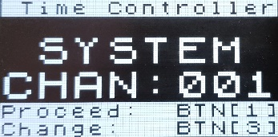
2nd Power on the Controller
fig 2
The ON button is located on lower side (fig 3)
[ Powering OFF is via 6sec hold of Red <BTN 4>
- only possible from the HOME screen (fig 3) ]
STANDARD OPERATION
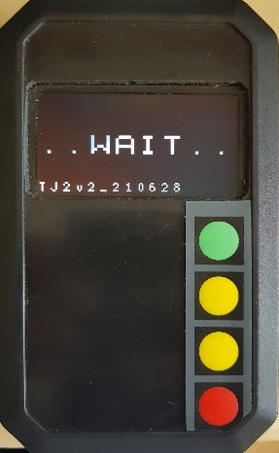
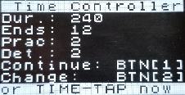

[Controller and Screen-unit(s) are turned on]
ON
Mini-USB chg.
fig 3
Typical HOME SCREEN
Current channel is accepted by depressing Green <BTN 1> the
system proceeds through the boot-up sequence, displaying:
SCREEN unit(s):
[
- Channel information
- The TimeJudge logo
- The current (or last used) competition parameters
- The TimeJudge logo
CONTROL unit:
- Channel information [& change channel locally]
- Boot-up WAIT message . . .
- . . .
- HOME Screen.
From this HOME-screen (indicated by the TIME_TAP now message):
- Green <BTN1> The currently selected parameters can immediately be run as displayed.
- New parameters may be selected by offering up the relevant TimeTAP card to the RFID zone on the front of the controller.
- Power OFF or Global Channel Change may be actioned (see p 5)
Using the TimeTAP card is the easiest and quickest method to change parameters.
Parameters may also be changed using Yellow <BTN 2> to enter Menu Mode and following the on-screen prompts:
- Yellow buttons - Up / Down Scroll through the menu options / Alter the selected parameter:
- Green <BTN 1> Alter the current selection / Accept a change:
- Red <BTN 4> Exit the menu mode to HOME:
TimeTAP offers extra options (Flint round, IFAF round, etc) that are not available through the menu alone and are available to purchase on-line from our web site www.tjudge.com.

Run a Competition:
Ensure you have the correct competition parameters selected and proceed:
Green <BTN1> :
- START the play
- PROCEED to the next step i.e.: Change detail from AB -> CD or vice-versa.
- CONTINUE the play after arrow collection.
- Next END
If everything is progressing normally the only button in play is the Green <BTN 1>

COUNTDOWN TIMER
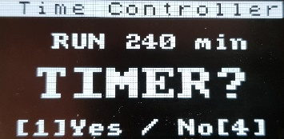
When a count-down to the tournament is required, or to run a mid-event break timer, there is a built-in on-screen count-down clock available.
- HOME screen
  - Yellow <BTN 3> to select COUNTDOWN (fig 4):
fig 4

- Duration Menu
  - Yellow UP/DOWN function (min: 3min, max: 4Hrs)
NOTE: <BTN 2> increments, +10 minute steps,
<BTN 3> decrements, - 1 minute steps.

- Green <BTN 1> begin COUNTDOWN:

  - Countdown will appear on the display screens.
    - When the count reaches 1 minute:
      - the screen will momentarily blank.
      - show the parameter setup.
      - flash a “PREPARE…” advisory for the archers.
    - From approximately 45s to end of timer period the screen will blank, showing a scrolling waiting indication, and this condition will last indefinitely until the operator continues by pressing:
      - Green <BTN 1> at the operator’s discretion to commence the shooting.

  - If the countdown timer is used for a mid-session break, the competition will automatically pick up where it left off.
For example: in a 12 End competition the break timer can be run after the 6th End.
After the interval runs out the competition clock picks up at the beginning of the 7th End.
During the countdown you may:
- Change competition parameters:
  - using a TimeTAP card, you may alter the setup without pausing the countdown timer.
This is useful if, for example, the competition is moving from Qualifiers to Finals after the current break period.
- Cancel the timer at any point:
  - Red <BTN 4> will bring you back to the HOME screen and clear the timer

EMERGENCY STOP: 

Red <BTN 4> will “break”, or halt operations:

- During an End if an emergency stop is required.
Play is HALTED with a 5-whistle signal and a Red visual No-Go;
Play may be restarted following the displayed prompts:
  - Green <BTN 1> RESUME play from elapsed time -10sec (if applicable)
  - Yellow <BTN 2> RESTART play from beginning of current END
  - Yellow <BTN 3> RESET play to beginning of the current COMPETITION
  - Red Re<BTN 4> OOPS: (Oh, &@$%! – I really did not mean that – please continue).

CHANGING CHANNELS: LOCAL & GLOBAL options:
Channel selection is important where more than one set of timing screens are being used in proximity, or in the extremely rare instance where other (433MHz) RF devices may be causing interference (wireless intercoms, walkie talkies, talk-back units etc).
- LOCAL channel change: To Change the channel on the CONTROLLER.

NOTE: This operation ONLY affects the CONTROLLER and does NOT affect any screen unit channels.
If the channel displayed on the Controller is not the chosen channel you may, immediately after powering up the Controller (fig 5):

fig 5
  - Yellow <BTN 3>: Enter Local Channel menu.
  - Yellow UP/DOWN: Select LOCAL channel
  - Green <BTN 1> ACCEPT change and PROCEED

- GLOBAL channel change: [SUPERVISOR MODE]



If any screen(s) display a different channel when they are powered on, they will need to be changed to match the channel in use.
CHANNEL: 011
CHANNEL: 006
CHANNEL: 006
fig 6
NOTE: This operation cannot be enabled without the Supervisor card; in this way the screen units' channel assignment cannot easily be altered in error.
Global Change example:
Three screens are to be used: Channel 6 is chosen as the working channel. (fig 6)
Here the screen-unit currently set to Ch 011 will first need to be changed to match the agreed frequency for the group: Ch 006
Note: There are 20 channels available from 001 in steps of 5: - 001, 006, 011 . . . 091, 096
This is simple to do and is clearly explained below.
- Pair the Controller to the unwanted channel (ex: CH 011) : see Local Channel Change (above).
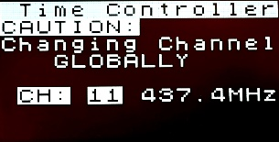
- Green <BTN 1>: ACCEPT change and PROCEED to HOME screen
- SUPERVISOR CARD: Enter GLOBAL CHANNEL CHANGE menu (fig 7)
- Yellow UP/DOWN: Select the desired channel (CH 006)
- Green <BTN 1>: ACCEPT change & return to HOME
This process will bring the channel on the Screen-unit and the Controller channel to the selected
Ch [ 006 in our example] and can be repeated as needed to match any un-paired screens to the desired channel.
fig 7
The control unit always powers up displaying the currently set Control channel number.

